Statistical Analysis Report

# STATISTICAL ANALYSIS OF OSTRICH

**BY.**

**April 2015**

**___________________________________**

Sept ____, 2015

# Table of Contents

STATISTICAL ANALYSIS OF OSTRICH 1

1 Table of Contents 2

**Part 1: POPULATION STRUCTURE**

Descriptive analysis

Male adults

N 97

Min 0

Max 8

Female adults

N 202

Min 0

Max 27

Juveniles

N 26

Min 0

Max 5

Chicks

N 17

Min 0

Max 4

N is the total number per age group.

Adult sex ratio;

For male: 97/ (97+202) =0.32 for female: 202/ (97+202) =0.68

This means that adult male ostriches comprised 32% whereas female adults were 68%. There were more females than males spotted.

Juvenile ratio to adults was 0.08 and chicks to adults were 0.06. From the data it is clear that there were very few chicks and juveniles traced during the study.

The highest group size was 37 and the lowest was 1.

Group size:

Mean 5.344

Min 1

Max 37

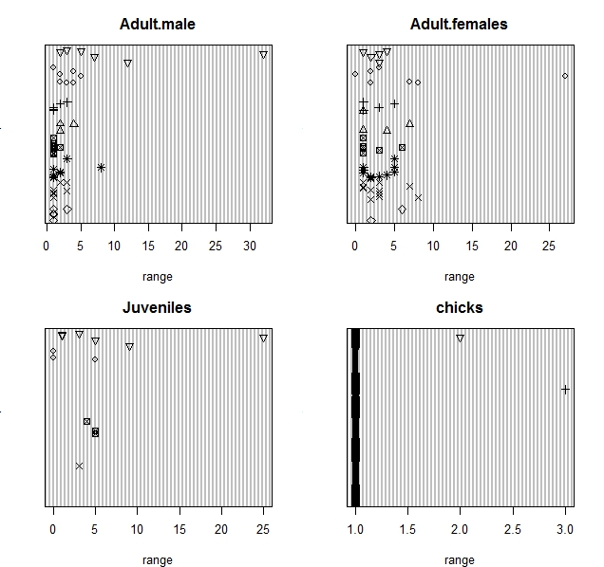

Figure 1.dotplot for Season variable and the age group

Cleveland dotplots (Cleveland 1985) are useful to identify outliers and homogeneity. Homogeneity means that the variance in the data does not change along the gradients. Violation is called heterogeneity; homogeneity is a crucial assumption for many statistical methods. For R, each observation is presented by a single dot. The value is presented along the horizontal axis, and the order of the dots (as arranged by the programme) is shown along the vertical axis. Cleveland dotplots for the abundance of four age groups are given in Figure 6 above. The data points (of season in month and age groups) are plotted along the vertical axes and the horizontal axes show the values for each age group. Any isolated points on the right- or left-hand side indicate outliers, and in this dataset, one or two of the points are considered outliers in each group. However, the dotplots also indicate a large number of zero observations. Also note that the plots show that *male adults* and *female adults* are considerably more abundant than the other two groups. The dotplots were made using different symbols conditional on a nominal explanatory variable, which in this case is season. The boxplots and dotplots for the ostrich data tell us that we have many zero observations, two groups have larger abundances than the other, there are no 'real' outliers, and there are differences in species abundances between the age groups and seasons.

Ostrich data from the three places was analyzed depending on ostrich’s age and sex. The data consist of this bird taken in Meibei, Westgate and Samburu national reserve in two seasons that is the wet and dry seasons. MA(Male Adult), FM(Female Adult), JU(Juveniles) and CH(Chicks) is shown in the box plots below: Note that the notches of the plots do not overlap, thus the medians are significantly different at the 5% (Chambers et al. 1983).

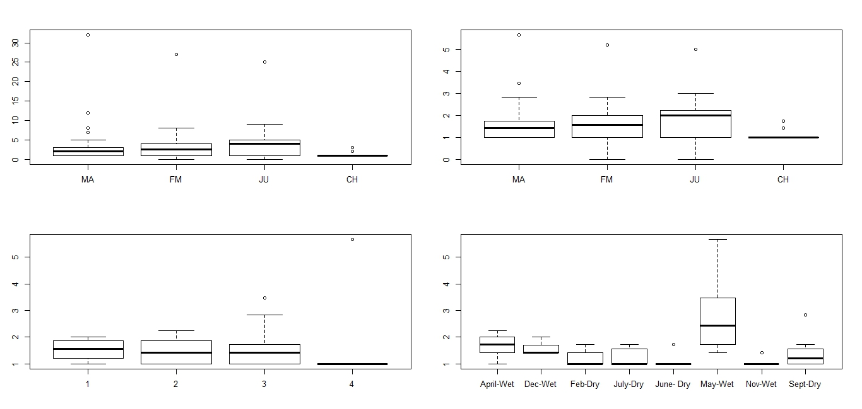

Figure 4.boxplot for Season variable and habitat across the age groups

Panel A shows that some the male and female adults as well as the juveniles have potential outliers, which prompted an inspection of the original data to check for errors in data entry. After checking, it was concluded that there were no data errors. However, the presence of outliers (or large observations) is the first sign that we may need to transform the data to reduce or down-weight its influence on the analysis. We decided to apply a square root transformation, and boxplots of the transformed data are shown in Panel B. Note that the boxplots for the transformed data show that this has removed many of the outliers as compared to Panel A. The large number of dots outside the interval defined by 1.5 times the range might indicate a large number of zero observations for *male and female adults.* This is called the double zero problem, but how big a problem this is depends on the underlying ecological questions. If two variables have many data points with zero abundance, the correlation coefficient will be relatively large as both variables are below average at the same sites. This means that these two variables are identified as similar, only because they are absent at the same sites. It is like saying that butterflies and elephants are similar because they are both absent from the North Pole, the Antarctic and the moon. It sounds trivial, but the first few axes in a principal component analysis could be determined by such variables, and it is a common problem in ecological data of which we need to be aware.

Panel C in shows the boxplot of square root transformed total in the groups (*Male, female, juveniles and chicks)* abundance conditional on the nominal variable Habitat (1, 2, 3 and 4). It is readily seen that abundances are considerably lower in habitat 4.

Panel D takes this one step further; the same group is now plotted conditional on season. The plots shows abundance appearing more during the wet seasons compared to dry seasons. Although this shows differences in abundances between the seasons, it also shows there appears to be no seasonal consistency between the ostriches.

**Note:** *partially protected areas are Meibei and westgate whereas protected areas are Samburu national reserve (SNR).*



Protected area covered 28% of the research area whereas partially protected area covered 72%

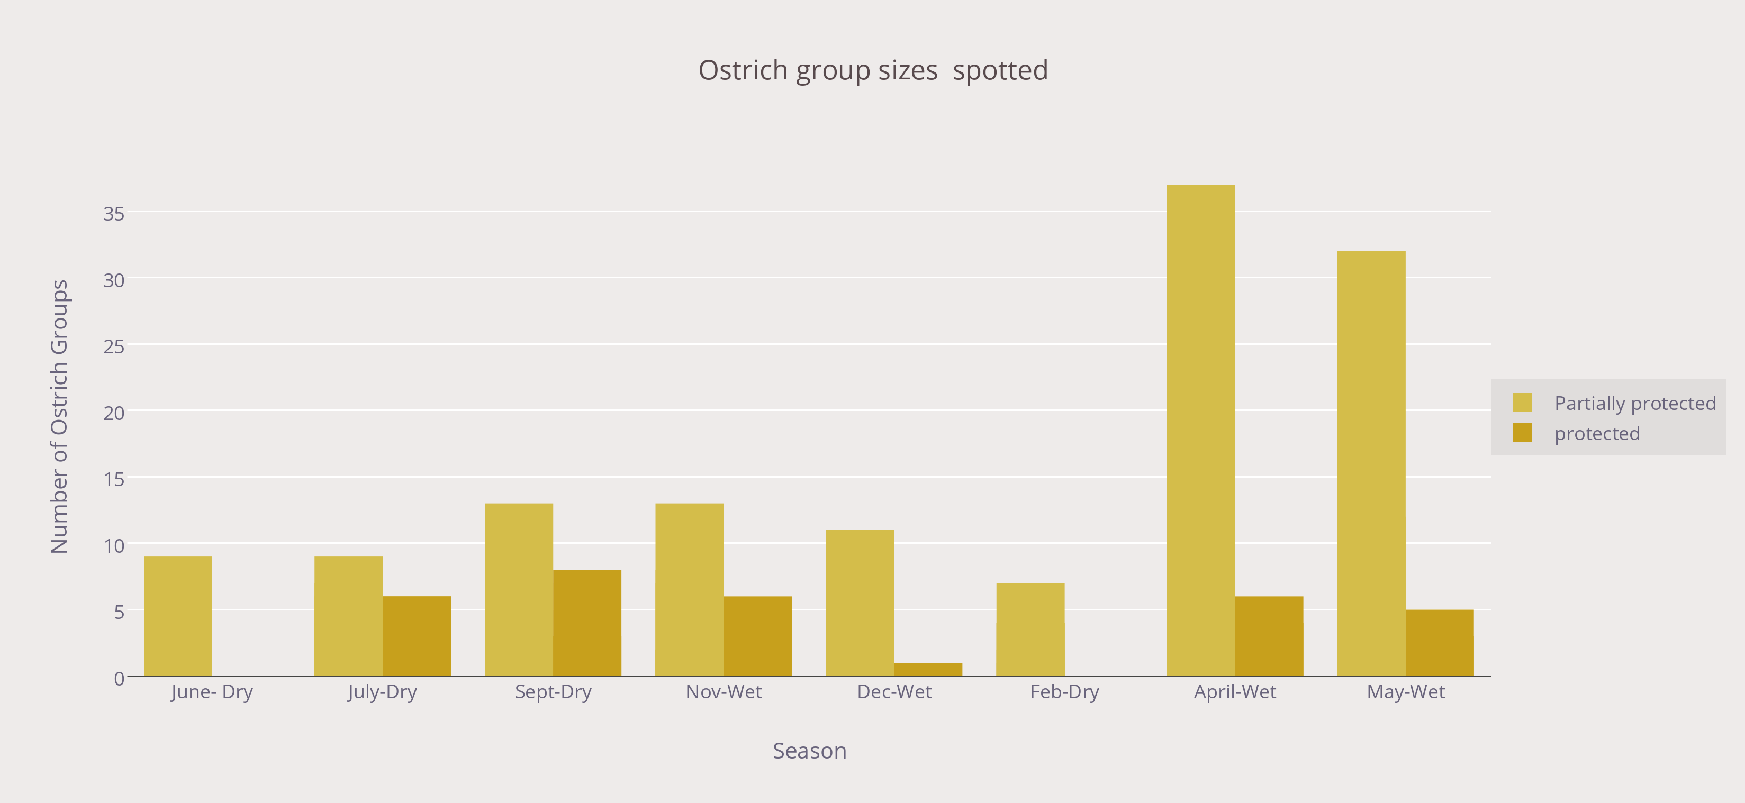

Most of the ostriches were spotted on the partially protected areas. This could explain perhaps the availability of predators on the protected area.

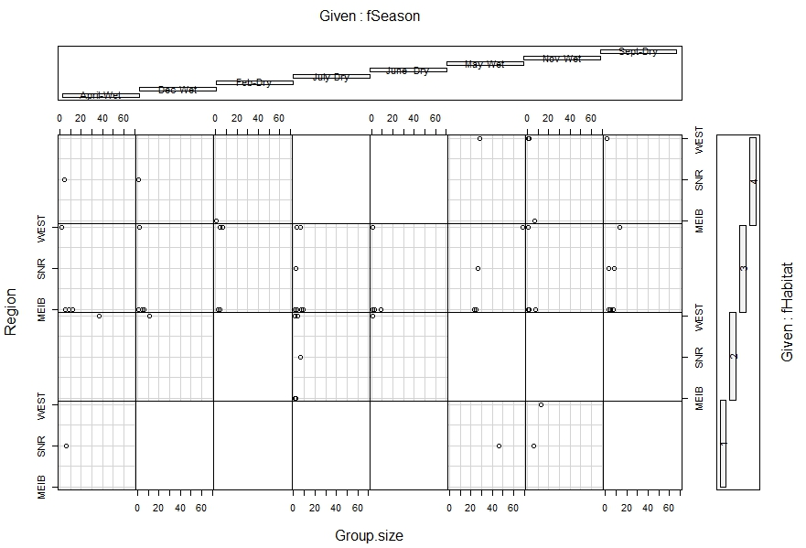

Figure 2.Coplot for region versus group size given the habitat and season

The lower left panel corresponds to April-Wet on habitat 1, the lower right to Sept-Dry on habitat 1. The upper left corresponds to April-Wet on habitat 4 and upper right to Sept-Dry on habitat 4. Note that the number of observations is different for each month. It is clear that most group sizes are twenty (20) and less across the regions. Most of these are found in Meibei area. As this relationship between Region and group size is common across all the seasons, it suggests that this may be influenced by season. The blank squares shows nothing was spotted at that particular region.

**Analysis of Variance Table**

Response: Ostrichs

Df Sum Sq Mean Sq F value Pr(>F)

Season 3 408.36 136.12 0.3341 0.8015

Residuals 7 2852.37 407.48

The ANOVA table (Table 1) shows that the ratio MS regression/MS residual is 0.3341.

Under the null hypothesis that all slopes are equal to 0, the ratio of 0.3341is unlikely

(p < 0.001), and H0 is rejected. This suggests that ostrich’s observed number changes in seasons. The visualization below helps to support this claim.

**Density on season and region**

**Comparing the combined adults during the dry and wet season**

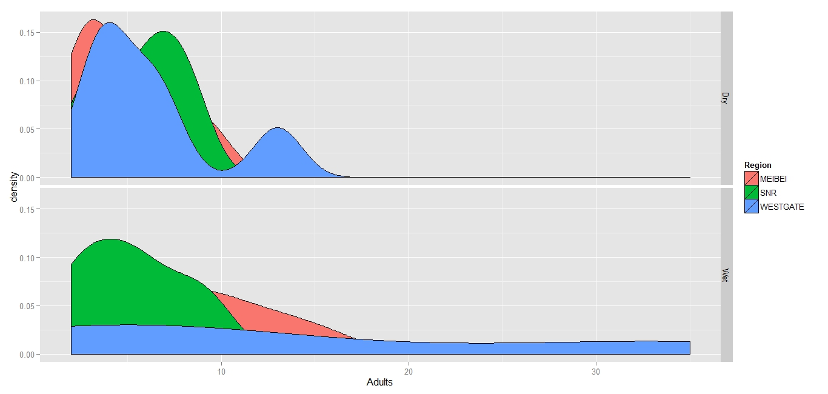

Figure 1.Area plot for adult ostrich’s abundance (female and male) across the Season

It is clear from the analysis that the highest number of ostriches are spotted during the dry season. Highest percentages of the ostriches were spotted at Westgate and lowest at Meibei.

**Comparing the combined Young and chicks during the dry and wet season**

**C:\Users\user\Documents\statistics\new report\2.tiff**

Figure 2.Area plot for young ostrich’s abundance (juveniles and chicks) across the Season

The highest number of juveniles and chicks were spotted during the wet season with a high number of these ostriches being spotted in Westgate and Meibei. Nothing much was seen in the dry season.

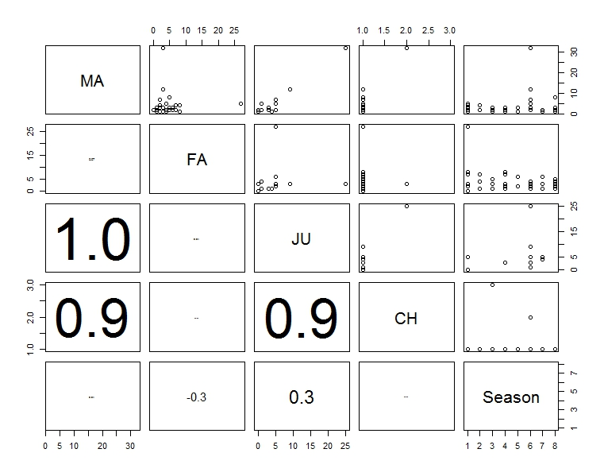

Figure 3.Pairplot for Season variables in the ostrich data

MA(Male Adult), FA(Female Adult),JU(Juveniles) and CH(Chicks)

The lower diagonal part shows the (absolute) correlation coefficient and the upper diagonal part the scatterplots. The font size of the correlation is proportional to its size. There is strong collinearity between juveniles and chicks in the age group variable and the season. The juveniles have a correlation of 1 and the chick 0.9 which is shows a very high correlation value. This will therefore be verified by poisson test and chi test.

**Backwards model selection using F test**

This is used to test the best fit variables that affect the ostrich number.

Model:Ostrichs ~ Season + Region + factor(Habitat)

Df Sum of Sq RSS AIC F value Pr(>F)

<none> 549.04 59.013

Season 2 818.34 1367.38 65.050 2.2357 0.2544

Region 2 338.53 887.58 60.297 0.9249 0.4865

factor (Habitat) 2 1806.65 2355.70 71.034 4.9358 0.1125

Each row compares the full model versus the model with one variable dropped. For example, leaving out Season resulted in an F-statistic of 2.2357. Results indicate that habitat is the most significant variable followed by season and region seemed to be the lowest variable. This could mean that region has almost the same weather conditions that affect the Ostriches but all over all they all are significant.

**Further analysis**

Comparing on the chi square that is Pr>(Chi) we find the following results:

Model: Ostrichs ~ Season + factor (Region) + factor (Habitat)

Df Deviance AIC LRT Pr(>Chi)

<none> 9.531 72.907

Season 2 38.152 97.528 28.621 6.095e-07

factor (Region) 2 19.363 78.739 9.832 0.00733

factor (Habitat) 2 96.415 155.791 86.884 < 2.2e-16

---

This means that if all explanatory variables are used, the deviance is 9.531. Each explanatory variable is deleted in turn. For example, if habitat is dropped the deviance increases to 96.415, which is an increase of 86. 884. This difference follows a Chi square Poisson regression 85 square distribution with 2 degree of freedom. The associated *p-*value is 2.2e-16 such a small figure indicating strongly that you cannot reject the null hypothesis at the 5% level, and that the regression parameters for Habitat are zero. This confirms our initial statement that these variables are affecting the Ostrich numbers. This, together with all other variables being significantly different from 0 at the 5% level, indicates that Habitat, season and Region cannot be dropped from the model. Clearly, Habitat as seen from the deviance is the most significant variable as seen earlier leaving it out results in the highest deviance, indicating the poorest fit.

**Habitat association**



Of the habitat, 64% of the ostriches were found in habitat 3, 15% were found in habitat 4 as well as habitat 2 and ostriches 5% were found in habitat 1. Most of the ostriches preferred habitat 3.

**Scatter plot of group sizes versus Adult Ostriches**

Of the four habitats shown below as 1-4;

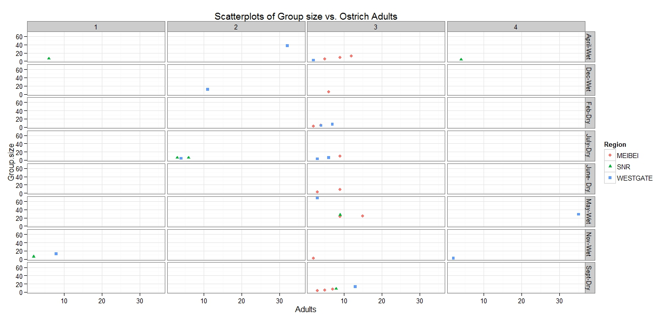

Figure 3.scatterplot for adult ostrich’s abundance per season factor being region (*i.e. the distribution on season and habitat*)

Most ostriches were found in habitat 3 and closer look shows that they were from Meibei and Westgate.

The lowest were spotted in habitat 1 and 4 and looking closer we see that it was around dry season with those spotted during the wet season mostly seen around April-wet and Nov-Wet.

**Ostrich behavior**

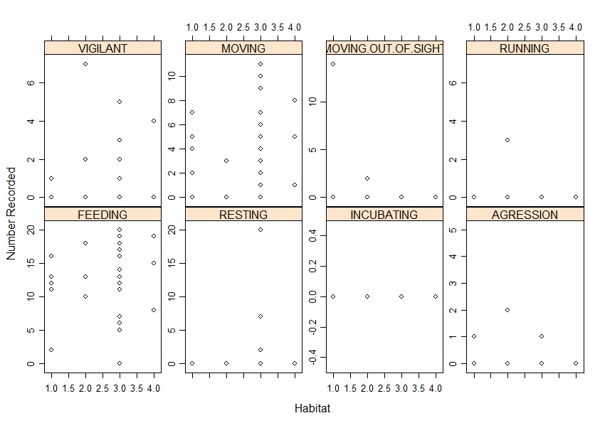

Feeding moving and vigilant are more prevalent behaviors across the regions.

We look at the time of the day for the data.

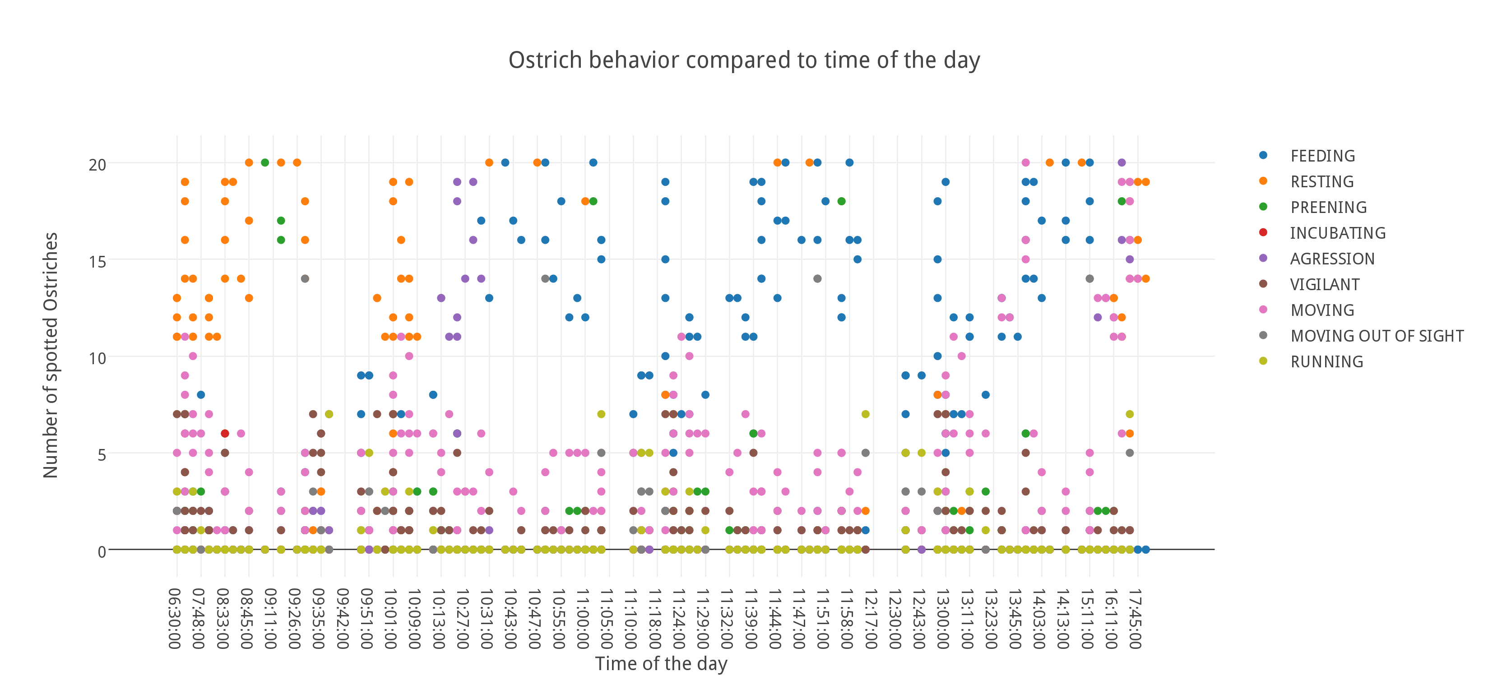

From around 6 to 10 am, most of the ostriches found were resting.

Between 10 to 10:30, ostriches were in aggression in high number, from 10:30 to 6pm, most of the ostriches were feeding. Few were found in the early hours to be incubating and later in the day from around 4 pm. few traces of running are experienced later in the day. There was some activity of preening in the morning hours between 9 and 10:30. Moving and vigilant can be seen from around 9am to 5pm.

**Plot of Age of respondents on duration of stay in village and if they encountered ostriches in the village**

All respondents said that they have encountered ostrich.

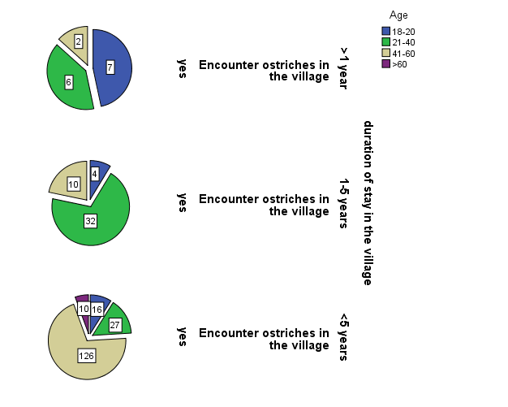

Checking the above visualization, (the numbers shown represent the count of people interviewed) it is clear that most of the respondents aged 18-20 said they leaved in the village less than 1 year. Most of the respondents aged 21-40 said they leaved in the village 1-5 years and those who have leaved in the village more than 5 years were aged 41-60. It is also clear that those above 60 said that they had leaved in the village more than 5 years. No one above 60 had leaved less than 1 year or between 1-5 years. This means that majority of those interviewed have been leaving in the village that they interviewed. Looking closer, we deduce that most of those interviewed were between the ages of 41-60. As shown below representing a 58%.

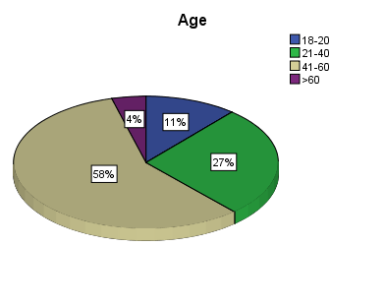

**How often you encounter ostriches**

|  |  |  |  |  |
| --- | --- | --- | --- | --- |
| **How often you encounter ostriches** | | | | |
|  | | Frequency | Percent |
| Valid | Rarely | 30 | 25.0 |
| Once in 2-3 days | 40 | 33.3 |
| Everyday | 50 | 41.7 |
| Total | 140 | 100.0 |

Around 42% of the respondents said that they encountered ostriches every day another 33% said they encountered ostriches once in 2-3 days and 25% said they encountered ostriches rarely. This shows that most of the villagers encounter ostriches. This means that they continue to breed.

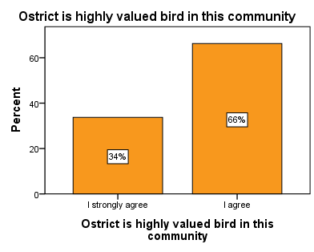

All the people agreed that ostrich is highly valued in the community.

|  |  |  |  |  |
| --- | --- | --- | --- | --- |
| **Ostrich products Frequencies** | | | | |
|  | | Responses | | Percent of Cases |
| N | Percent |
| Ostrich products used or sold in the coma | Egg | 73 | 16.8% | 30.4% |
| Egg shells | 127 | 29.2% | 52.9% |
| Feathers | 222 | 51.0% | 92.5% |
| Meat | 13 | 3.0% | 5.4% |
| Total | | 435 | 100.0% | 181.3% |

Most of the people use feathers at 51% followed by egg shells at round 29%, eggs at around 17% and least product used or consumed is meat at 3%. This means that majority of the people in the community do not hunt or kill ostriches. This is verified by the below visual.

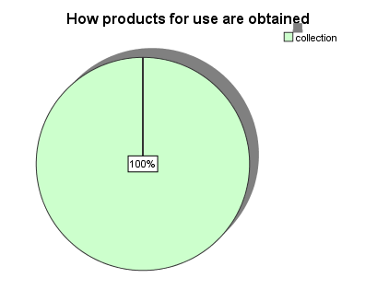

Which shows that all the people obtain the product by collecting no one said killing.

|  |  |  |
| --- | --- | --- |
| How ostrich products response  are used | | % |
| How Eggs are used among my community | Not aware | 78% |
| sold to foreigners | 17% |
| used as food i.e. cooked | 5% |
| How Egg shells are used among my community | Not aware | 33% |
| used for cultural activities | 8% |
| used for decoration | 58% |
| How Feathers are used among my community | during circumcision | 83% |
| used for cultural activities | 17% |
| How meat are used among my community | Not aware | 95% |
| Some communities feed on meat | 5% |

On how ostrich products are used; 17% said that they sold eggs to foreigners while 5% said they used eggs as food. On how egg shells are used among the community, 58% said that they used them for decoration and 8% said that used egg shells for cultural activities which they had not specified. On how feathers are used among the community, 83% said that they used them during circumcision, even those who said that they used them for cultural activities, may have been implying the same. Those who consumed meat were simply feeding on it and comprised only 5%.

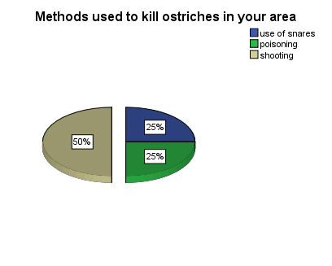

Most of the respondents (50%) said that those who killed ostrich did it by shooting. 25% said they used snares and another 25% said they did it by poisoning the ostrich.

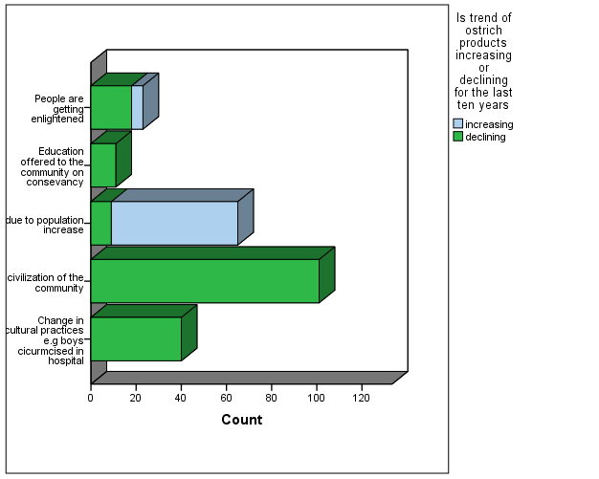

Almost all people said they agreed that the trends are declining. Those who said it was increasing said that the factor was due to population increase. Those who said that it was declining majority at 42% said that it was because of civilization in the community, 17% said it was because of change of cultural activities such as boys being circumcised in hospital, 10% said people got enlightened and 5% said it was due to education on conservancy as shown below.

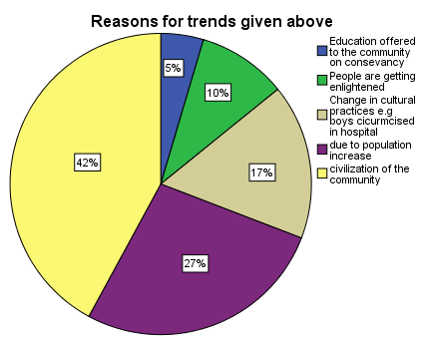

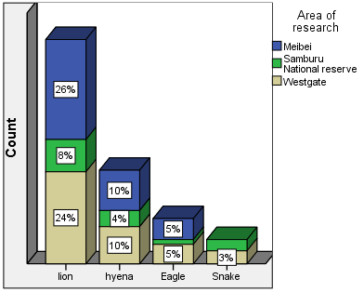

The highest number of people interviewed said that lion was ostriches’ predator at 58%, of those highest number came from Meibei area at 26%. Hyena was the second at 24%, eagle was third at 10% and snake was last at 3%. This means that the highest numbers of ostriches are killed by lions.

|  |  |  |  |  |
| --- | --- | --- | --- | --- |
| **If you encounter these predators in your village** | | | | |
|  | | Frequency | Percent |
| Valid | no | 40 | 16.7 |
| yes | 200 | 83.3 |
| Total | 240 | 100.0 |

Around 83% said that they encountered ostrich predators in their area and around 16% said that they did not encounter these ostrich predators. This means that these predators are existing in the around village.

|  |  |  |  |  |
| --- | --- | --- | --- | --- |
| **how often you encounter predators** | | | | |
|  | | Frequency | Percent |
| Valid | Once in 2-3 days | 70 | 29.2 |
| Once in a week | 70 | 29.2 |
| Rarely | 100 | 41.7 |
| Total | 240 | 100.0 |

Around 29% said that they saw these predators once in 2-3 days and another 29% said that they saw them once in a week with 41% saying that they encounter them rarely.

|  |  |  |  |  |
| --- | --- | --- | --- | --- |
| **other information regarding ostrich in your area** | | | | |
|  | | Frequency | Percent |
| Valid | Ostrich provide security warning during herding | 16 | 6.7 |
| Ostrich are a blessing in samburu community | 17 | 7.1 |
| report indicate people are poaching eggs for sale | 18 | 7.5 |
| Ostrich disappear sometimes due to climate change | 21 | 8.8 |
| Ostrich should be protected from predators within the locality | 40 | 16.7 |
| None | 128 | 53.3 |
| Total | 240 | 100.0 |

On any other information regarding ostrich in the area, around 17% said that Ostrich should be protected from predators within the locality, around 9% said that Ostrich disappear sometimes due to climate change, around 8% said that report indicated people are poaching eggs for sale, around 7% said that Ostrich are a blessing in Samburu community and another 7% said that Ostrich provide security warning during herding.

**Flight Initiation distance**

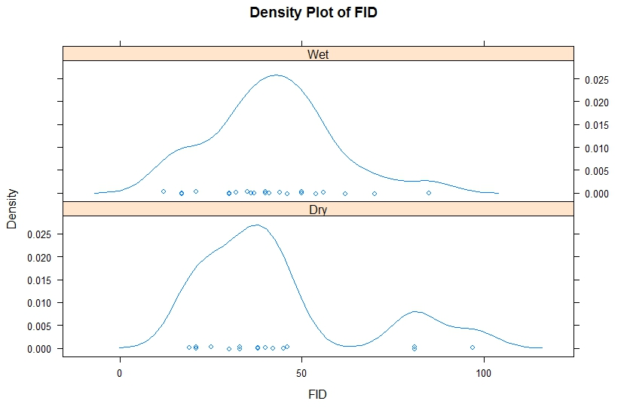

Most of the ostriches flee before 50 metres after they spot the person.

There is a slight difference during the seasons as shown above that the ostrich take flight earlier during the dry season than during the wet season as seen in the curves above. Ostriches can be seen to take flight even above 100 metres during the dry season which is not reflected in the wet season. Perhaps this could be a reflection of growth of plantation during the wet season which makes it harder to spot a person or predator.